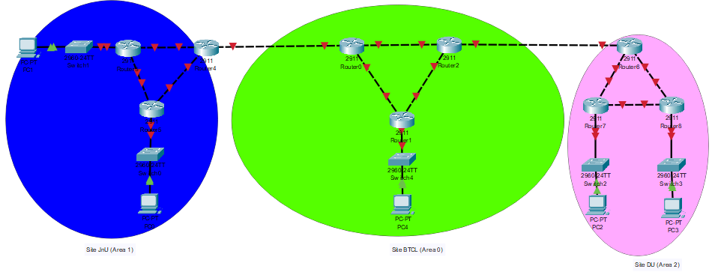

Consider the above network topology containing three sites (JnU, BTCL, and DU). The allocated blocks of three sites are as follows:

JnU: 1XY.XY.0.0/20

BTCL: 1YX.YX.0.0/16

DU: 1XY.YX.0.0/20

Design the subblocks and give the slash notation for each subblock in different sites. All the point-to-point connections address should be allocated from this granted block. Implement the network topology in packet tracer and test data transmission among different networks using M**OSPF routing protocol**.

(config)# **router** **ospf** process_id

(config)# **network** network_address wildcard_mask **area** area_ID

(config)#router-id IP_Address [usually the first address of the network]

[Wildcard mask: subtract the subnet mask from 255.255. 255.255]